Please read this brief carefully before completing the role

JOB: RETAILER NAME - check branded point of sale for xxxx - complete by xxx - £10/call
RETAILER: Insert retailer name
PRODUCTS: Insert name of brand / products to check
COMPLETION: Insert date to be completed by or dates from / to to complete
PAY: £10 (min we’d suggest)
EXPENSES: N/A – no purchase required

OVERVIEW / BACKGROUND TO THE CALL
INSERT HERE details around what the purpose of the visit is to give the worker some background.
For example…
We’ve currently invested in some branded point of sale to highlight our XXXX in-store so it’s more visible for customers. We’re wanting to visit stores to check that the product is in-store and available for customers to purchase, and that the point of sale we’re expecting to be there is present.
If the product isn’t available then we’d like you to speak to colleague to ask them for it
INSERT IMAGE OF YOUR PRODUCTS – it makes it easier for workers to find them in-store
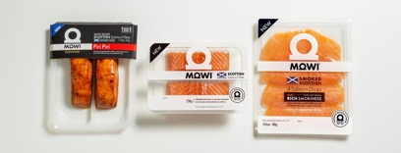
WHAT DOES A GOOD JOB LOOK LIKE:
INSERT HERE what success looks like – keep it brief & clear what your expectations are
For example…..Product X on sale with the correct price ticket / point of sale. Clear photos to show product and point of sale. You’ll need to speak to a colleague as a shopper to understand / rectify any issues

PRODUCTS TO CHECK:
INSERT table here with product name / pack size / weight / retail price
e.g MOWI Natural Fresh Fillets 230g
MOWI Cold Smoked Salmon slices 100g
MOWI Piri Piri slow roast Salmon fillets 180g

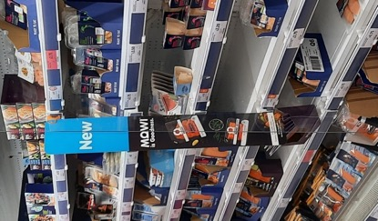
LOCATION: XXXX Fixture

WHAT POINT OF SALE ARE YOU LOOKING FOR?:
INSERT HERE WHAT THE WORKER IS CHECKING, E.G
- NEW Barker
- Promotional Barker
- Aisle fin
INSERT IMAGES OF WHAT POS / EQUIPMENT THEY ARE CHECKING

Figure 1- This is the Shelf Barker
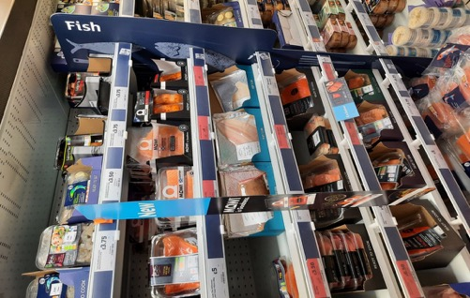
REQUIREMENTS OF THE ROLE:
- Go into the allocated store & head to the XXXX fixture (if it’s an unusual location then please describe where to find it)
- Take a photo of the product on shelf
- Take a photo of the wider fixture so we can see what else is present (we need a photo of the fixture whether the product is there or not)
- Is there a XXX branded aisle fin? Take a photo if so
- Is there a XXX branded “NEW” Shelf barker fin? Take a photo if so
- Is there an SEL (price ticket) for the product?
- Is the SEL correct? £INSERT EXPECTED PRICE
- If the product is missing or doesn’t have a price ticket, please ask a colleague if they can help you. (Record all details & who you spoke to)
  - Scenario 1: You know this is a new product in-store but can’t see it on the shelf, can they see if it is in the back for you, or can they order it in?
  - Scenario 2: Can they check the price for you as there is no price ticket on the shelf, so they may want to put one out
- Tidy up the fixture & then take another picture of the products close up & from a distance so we can see what is around them.
- Complete / submit your reporting questions / timesheet

REPORTING QUESTIONS
- What date did you visit the store?
- Time of visit
- Close up photo of products on XXX Fixture on ENTRY
- Photo of the XXX fixture showing adjacent products and any POS
- Is there a XXX Branded Aisle Fin present by the products? (as shown in the brief)
- Image of Aisle Fin
- Is there a XXX Branded “New” Shelf Barker present by the products? (as shown in the brief)
- Image of Barker
- Was “XXX”available?
- Was there a price ticket for XXX?
- What was the price? (£X.00, £X.00, other, n/a)
- Was “XXX”available?
- Was there a price ticket for XXX?
- What was the price? (£X.00, £X.00, other, n/a)
- If any of the products are not available on the fixture who did you speak to in-store?
- What did they say? Can they look in the warehouse? Can they find the stock for you? Please note full details
- Photo of shelf on EXIT
- Wider photo of XXX aisle showing product on EXIT
- Any other comments or feedback?

Once we have verified this, you will be paid on the next payroll according to your preferences.
Thanks for being a part of the revolution! Don't forget to tell your friends/family about redwigwam & BRAND NAME

Many thanks,
The INSERT BRAND NAME Team

PLEASE DELETE THIS SECTION BEFORE SAVING YOUR FILE AS A PDF (remember to reduce the images as max file size is 5MB)
To get your job loaded & live please log into your account https://hirer.redwigwam.com/login/
On your dashboard go to JOBS – ADD A JOB, Select Sector – RETAIL, Select Job Type – MYSTERY SHOPPER,
Select template job - Retail - check branded point of sale for xxxx - complete by xxx - £10/call
You will then need to update the job according to your requirement and also ensure you amend the products / pricing in the reporting section too from XXXXs / ABC.
If you need help then please pop onto live chat or email catherine@redwigwam.com

